Arabic Language Basics

Section: L01

Assignment Date: 15/09/2021

Name: Talha Abdullah Punjabi

QUID: 201903446

Drill 6 (Unit 9)

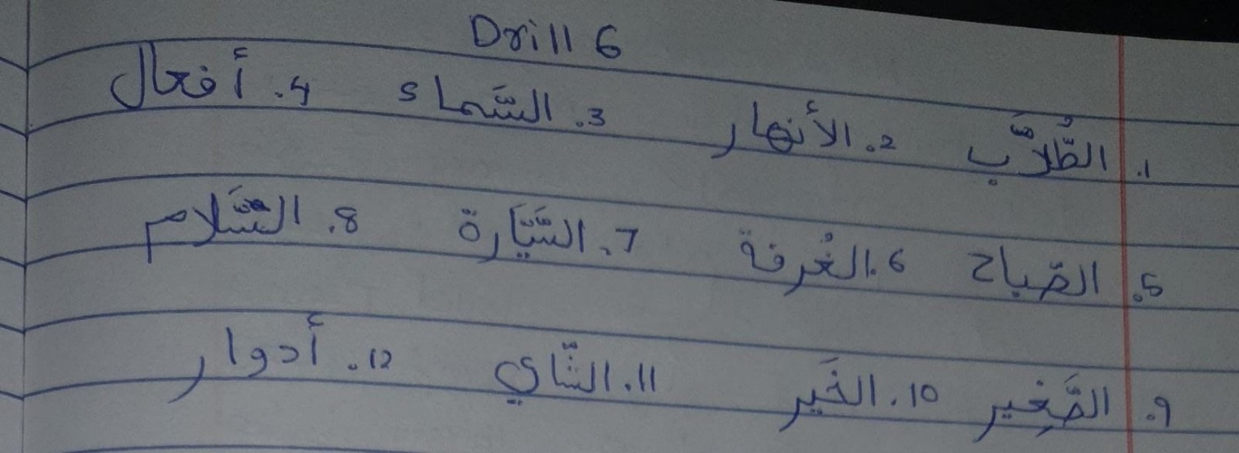

Drill 7 (Unit 9)

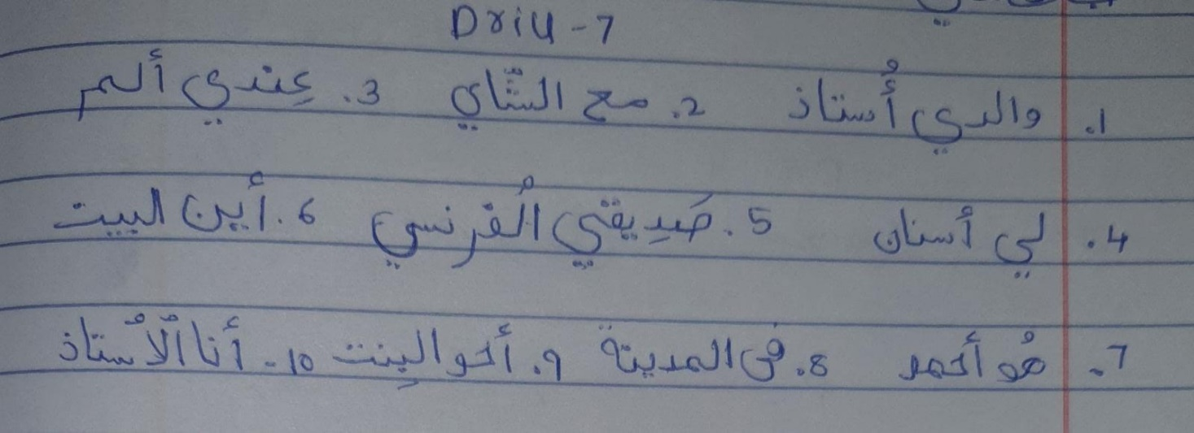

Writing Hamza Wasla